Lab 03
Relational Operators in C++
Title:
Study and Implementation of Relational Operators in C++
Objective:
To understand and implement relational operators to compare values in C++.
Theory:
Relational operators are used to compare two values or variables. The result of a relational expression is either true (1) or false (0).
- Common Relational Operators
- Operator
Meaning:
- Equal to
- Not equal to
- Greater than
- Less than
- Greater than or equal to
- Less than or equal to

Program:
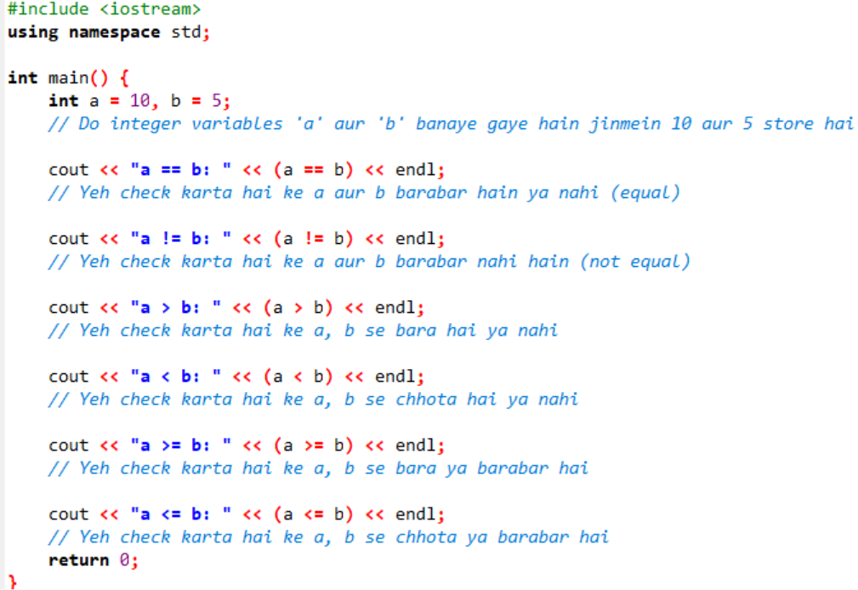

Output:
a == b: 0
a != b: 1
a > b: 1
a < b: 0
a >= b: 1
a <= b: 0

Conclusion:
Relational operators help in comparing values and are commonly used in decision-making statements.

Logical Operators in C++
Title:
Study and Implementation of Logical Operators in C++
Objective:
To understand and use logical operators to combine conditions.
Theory:
Logical operators are used to combine multiple conditions and return a boolean result.
Types of Logical Operators:
- Operator
- Meaning
- Logical AND
- Logical NOT
Program:
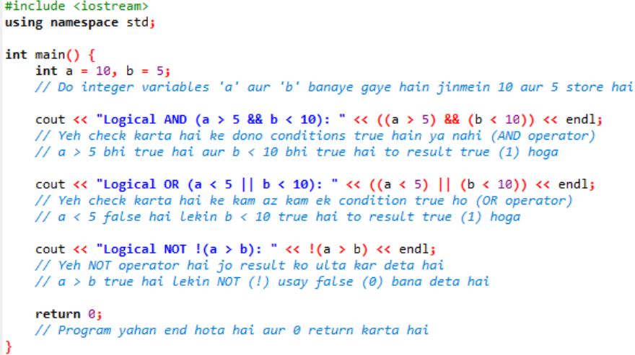
Output:
Logical AND: 1
Logical OR: 1
Logical NOT: 0
Conclusion:
Logical operators are useful for combining multiple conditions in programs, especially in decision-making.

Conditional Statements in C++
Title:
Study and Implementation of Conditional Statements in C++
Objective:
To understand decision-making using conditional statements like if, if-else, and switch.
Theory:
Conditional statements allow a program to make decisions based on conditions.
Types of Conditionals:
- if
- else if
- if-else
- switch

Program 1:
if-else
Code:
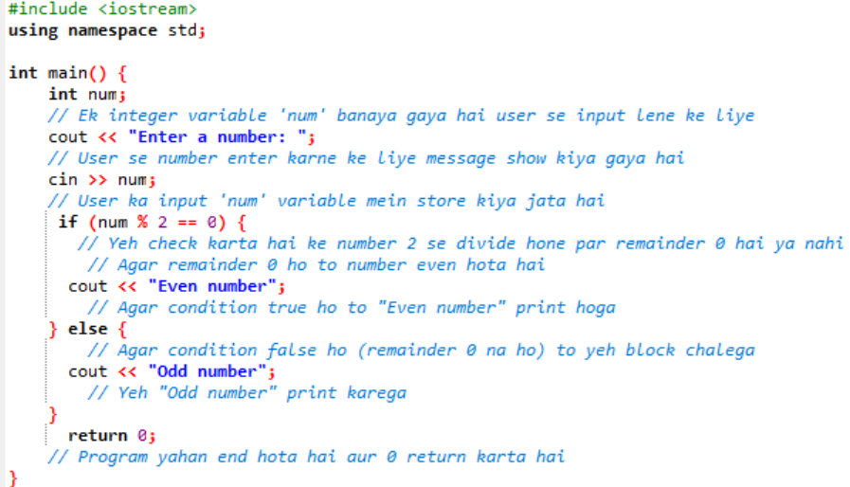
Program 2:
else-if
Code:
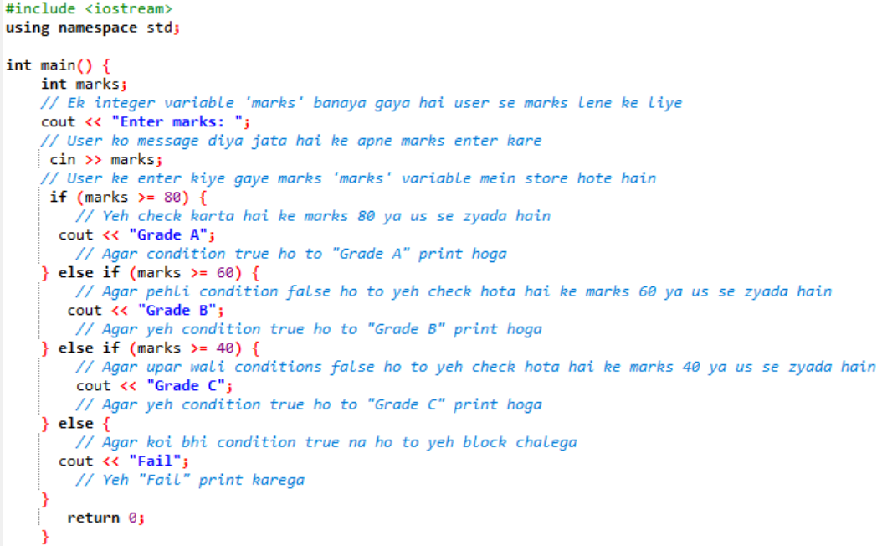
Program 3:
switch statement
Code:
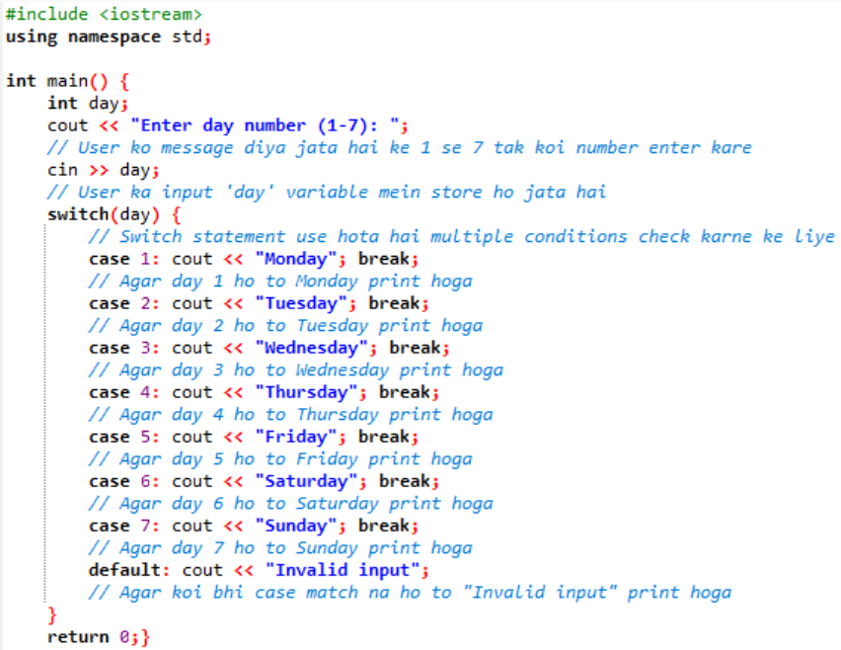

Conclusion:
Conditional statements are essential for controlling the flow of a program and making decisions based on user input or conditions.

Lab Tasks:
1:Comparison/Relational Operators
- Write a C program that prompts the user to enter two numbers.
- Use comparison operators to check if the first number is equal to, greater than, or less than the second number.
- Display appropriate messages based on the comparison results

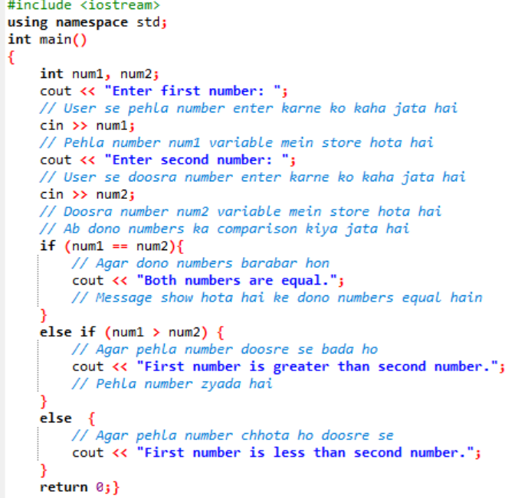
2: Logical Operators
- Write a C program that prompts the user to enter an integer.
- Use logical operators to check if the entered number is greater than 0 and less than 100.
- Display a message indicating whether the number meets both conditions or not.
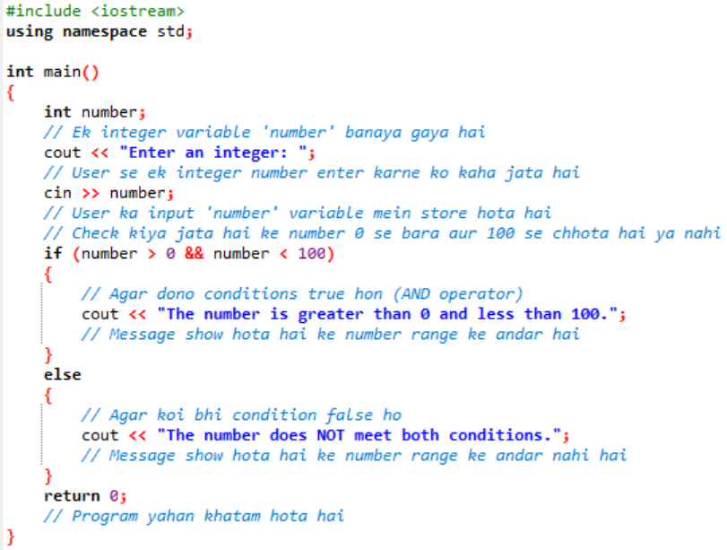
3. If Statement
- Write a C program that prompts the user to enter an integer.
- Use an if statement to check if the entered number is positive.
- Display a message indicating whether the number is positive or not.
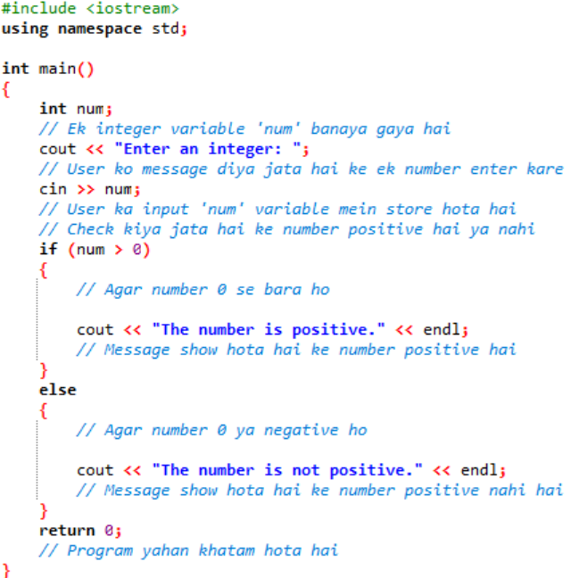
4. If-else Statement
- Write a C program that prompts the user to enter their age.
- Use an if-else statement to check if the entered age is greater than or equal to 18.
- Display appropriate messages for both conditions.
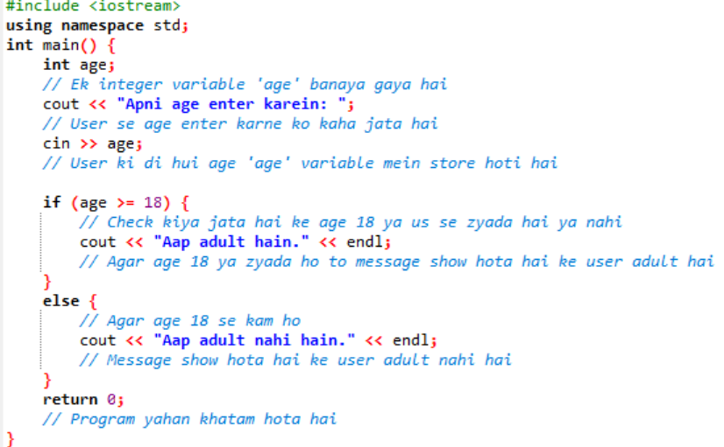
5. Else-if Statement
- Write a C program that prompts the user to enter an integer.
- Use an else-if statement to check if the entered number is positive, negative, or zero.
- Display appropriate messages based on the entered number.
